**Activity 20**

**NAME : M.Varshini COURSE : Mobile Computing Reg No : 192421293 COURSE CODE: ITA0302**

Design a wireframe in Figma for a mobile application showcasing power management Approaches.

**Aim:**

Design a wireframe in Figma for a mobile application showcasing power management Approaches.

**Procedure:**

1. Create a file
2. Add The First Frame
3. Add Shapes
4. Add Text
5. Create The Second Frame
6. Add Prototyping

Step By Step Procedure :

**Interface Of Experiment**

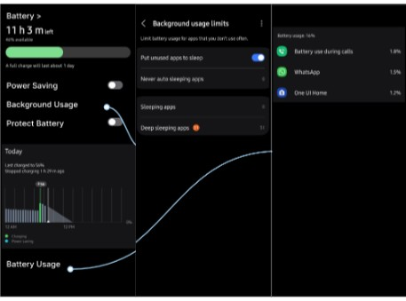

**Prototype:**

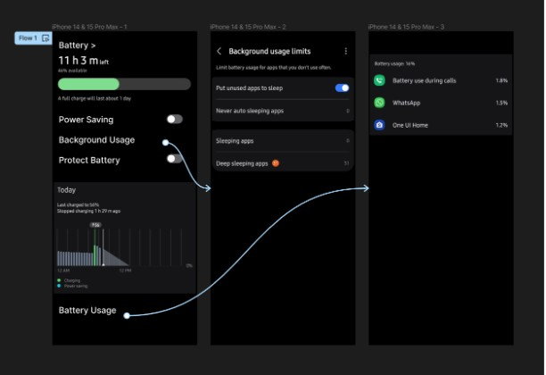

**Result:**

Hence the mobile application showcasing power management is created and executed successfully.